**This file can be also found on GoogleDrive - EOSREAL EOS Canada on Gov**

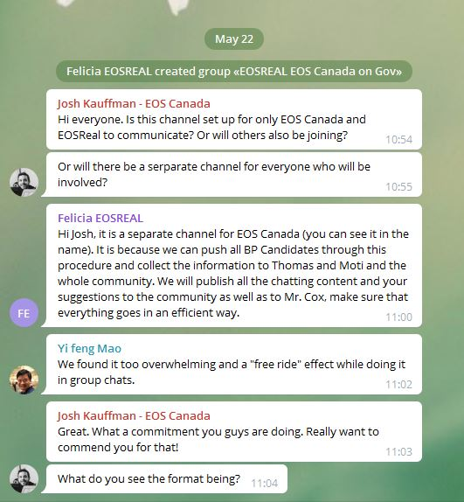

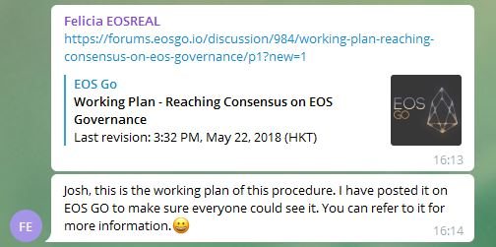

**EOSREAL EOS NATION on Gov**

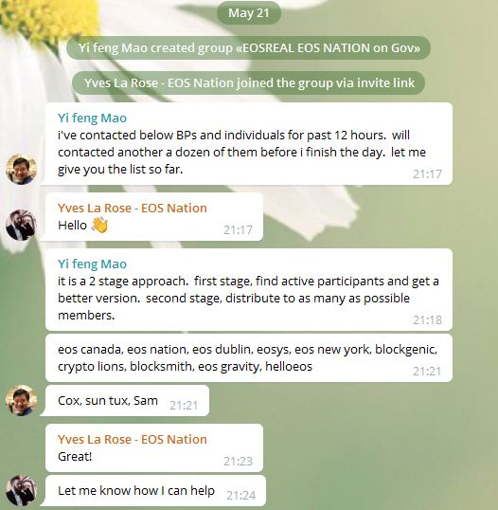

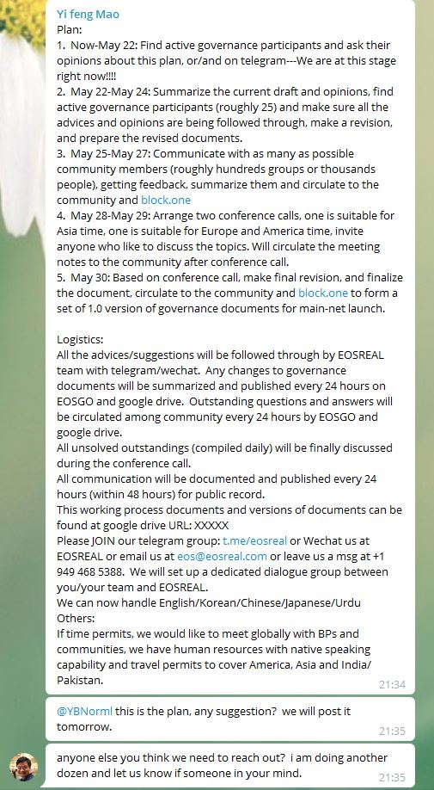

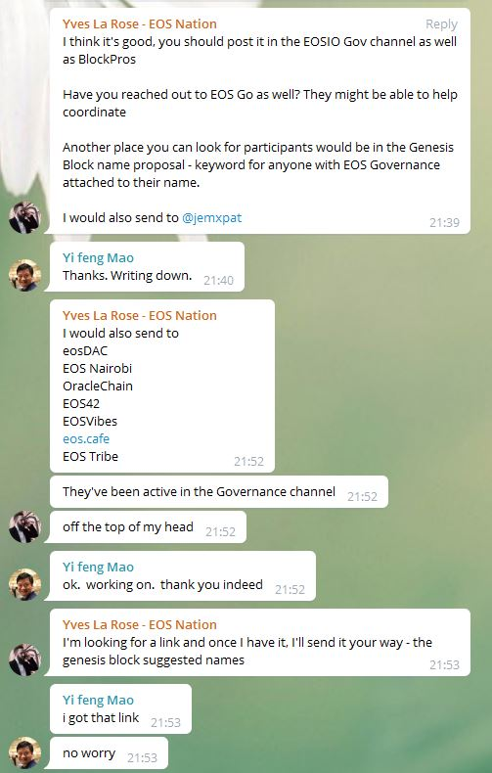

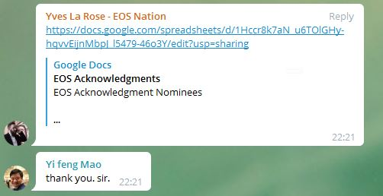

**EOSREAL EOSDUBLIN on Gov**

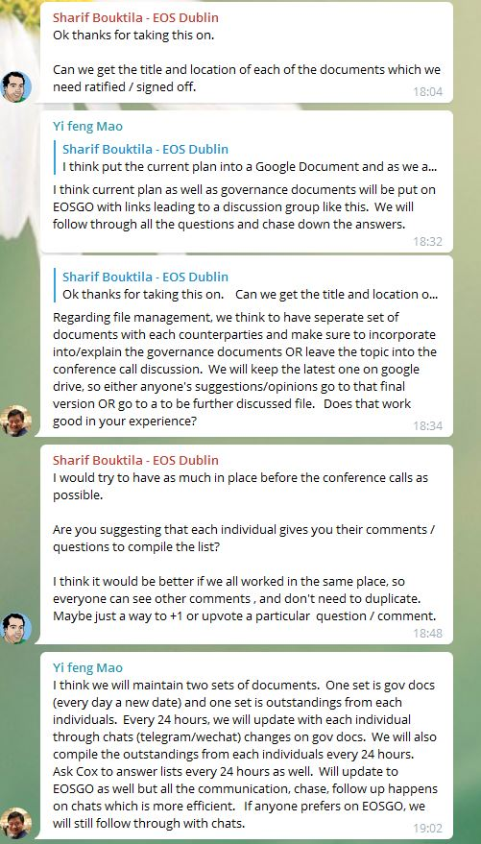



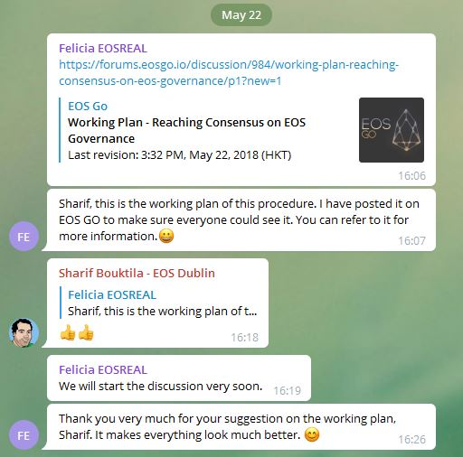

**EOSREAL SFEOS on Gov**

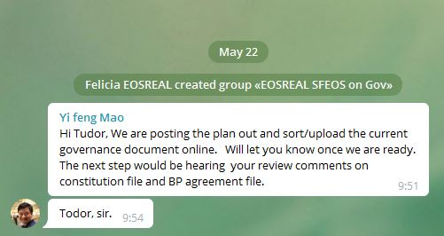

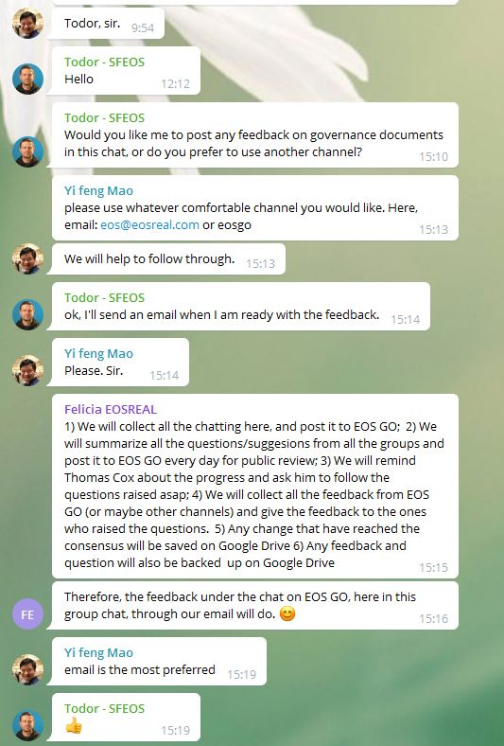

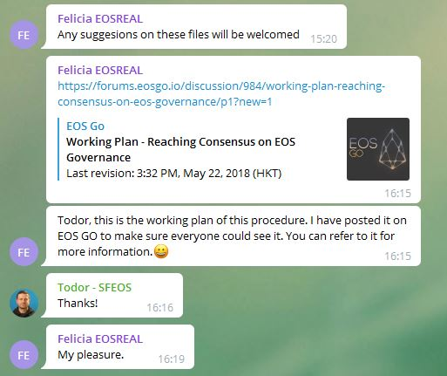

**Article I - No Lying:**

I don't approve of this article in its current form. It can lead to a lot of accusations and mud-slinging, with people calling on this article to prosecute others. It is almost impossible to prove that someone has knowingly said a lie, especially if the scope is all communication. I would prefer an approach similar to the one taken by CAcert:

<http://wiki.cacert.org/AssuranceHandbook2#CAcert_Assurer_Reliable_Statement_-_CARS>

|  |
| --- |
| [AssuranceHandbook2 - CAcert Wiki](http://wiki.cacert.org/AssuranceHandbook2#CAcert_Assurer_Reliable_Statement_-_CARS)  wiki.cacert.org  This is the practices handbook for Assurance, authorised under Assurance Policy. This is a working document for us Assurers. It will likely always be in need of help! |

I don't think that we can change this article in a meaningful way to support this approach. This is more relevant to users with special permissions, such as arbitrators and BPs, so it should probably be moved to the BP agreement / arbitrator agreement. I suggest removing this article from the constitution.

**Article II - Property Rights**

I disapprove of the word "sacred". It has religious connotations and in my opinion has no place in a governance document. I would suggest replacing it with another word, such as "invioable".

**Article VII - Agreement to Penalties**

I would suggest giving more clarity to this text, stating explicitly that members agree to suffer the penalties. Suggestion for new text:

Each Member agrees to conform to penalties imposed upon them for violations of the Constitution or any other governing documents relevant to their role. These penalties may include, but are not limited to, fines, account freezing, and reversal of transactions.

**Article XIV - No Positive Rights**

I believe this article is a contradiction. Users that have special permissions on the blockchain do have positive rights - for example, arbitrators have the right to impose penalties on others. The article itself doesn't serve any specific purpose and can only be used to dispute other governance documents. I suggest removing this article.

**EOSREAL Blockgenic on Gov**

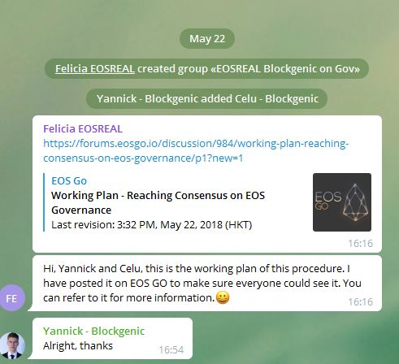

**EOSREAL EOS Detroit on Gov**

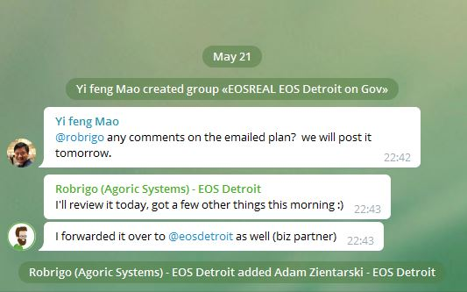

**EOSREAL New York on Gov**

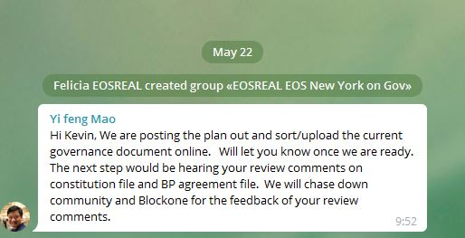

**EOSREAL EOS Tribe on Gov**

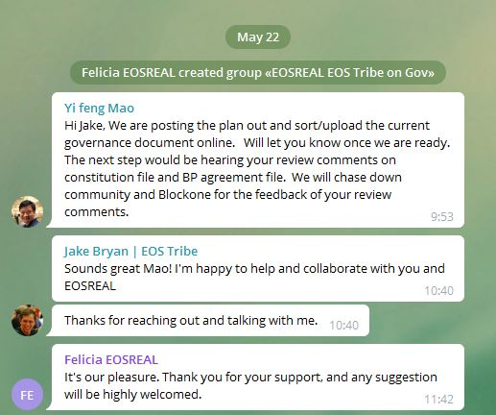

**EOSREAL Moti on Gov**

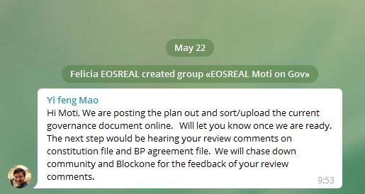

**EOSREAL**

